https://superuser.com/questions/498481/how-can-i-create-transparent-images-in-ms-paint:
How can I create transparent images in MS Paint?
I want to know how to draw transparent images in Microsoft Paint for Windows 7.
I searched on Google but couldn't find anything for Microsoft Paint in Windows 7.
E.g. I want to draw a star for my application. But I want that when I display it on black background then there should be no rectangular image with a white background and a star on it. It must be a proper star.
6 Answers
- Try Paint.NET for size. I tried GimpShop before, but did not like it. Paint.NET is to MS Paint what Notepad++ is to Notepad :)
To change an image to have a transparent background:
- Install Paint.NET
- Download AlphaMask plugin
- Extract AlphaMask.dll to \Paint.NET\Effects (note you will likely need to unblock the file)
- Open Paint.NET
- Open your file
- Copy the content you want to make have a transparent background (ctrl+a, ctrl+c to select all and copy)
- Effects Menu > Alpha Mask...
- check Invert Mask, check Mix Alpha, leave checked Paste from Clipboard
- Click OK
- File Menu > Save as, save as type PNG (*.png)
- Defaults are fine, OK one last time
source
Rather than deal with Paint, you should try GIMP.
http://www.gimp.org
It allows you to set any color you want to transparent so you can just fill the background of the image with some radical green or pink or something that doesn’t show up anywhere in your star and then set that color to transparent.
Since you’re dealing with image manipulation for applications I would also recommend it because it just generally has more functions and better support than Paint, and its free.
This documentation shows you the menu, and what you'll want to do is click 'color to alpha' where you can enter the color code (get it with the eyedrop tool) that you want to send to alpha (transparent)
http://docs.gimp.org/en/gimp-layer-transparency-menu.html
- The Windows XP version of MS Paint supports transparency. And users of Windows 7 Professional, Enterprise, or Ultimate can use the XP Mode feature of Windows 7 to run Windows XP in a window, run the old Paint there, and set the transparency of an image file:
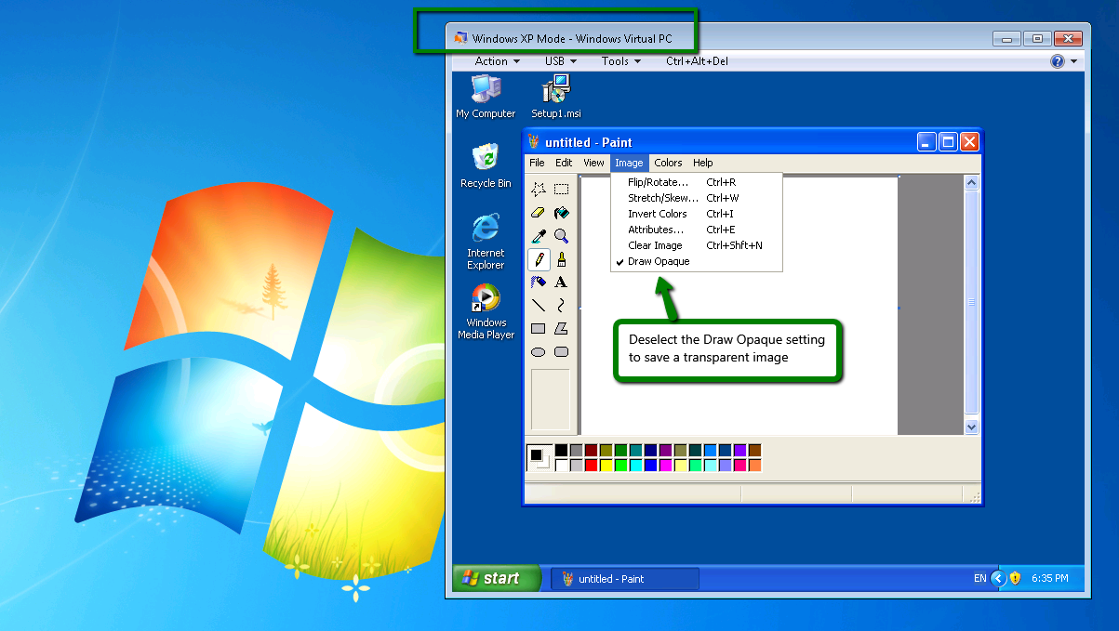
You can also run individual XP Mode applications directly from your Windows 7 Start menu, i.e., without explicitly launching XP Mode first.
If you haven't enabled XP Mode on your Windows 7 machine and wish to do so, you can get it free using the Microsoft instructions here. Do note the security advice on that page, remembering XP is now no longer supported.

